Waves are breaking on a submerged bar.

The onshore wave forces may be compensated by an onshore flow and a set-up over the breakwater.

*Could you imagine a situation in which the wave forces are for the larger part compensated by a set-up?*

|  |  |  |
| --- | --- | --- |
|  |  | yes, for a bar on an alongshore uniform coast |
|  |  | yes, for a bar delimited by rip channels |
|  |  | no |

Consider a horizontal wave-orbital velocity signal given by *u*(*t*)=*u1*cos(*ωt*)+*u2*cos(*2ωt-φ*) .

*u1* is 2 times larger than *u2*.

*A signal characteristic of shoaling waves is obtained for:*

|  |  |  |
| --- | --- | --- |
|  |  | *φ=π* |
|  |  | *φ=π/2* |
|  |  | *φ=3π/2* |
|  |  | *φ=0* |

For regular waves normally incident to an alongshore uniform coast, the below picture shows the cross-shore distribution of n (the ratio between group and phase velocity), shore-normal radiation stress Sxxand wave energy E.

The subscript ‘0’ refers to deep water conditions.

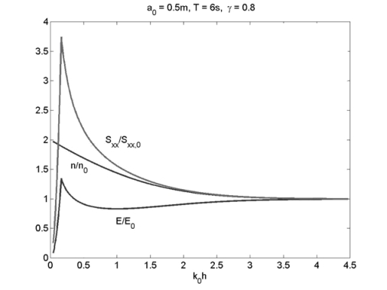

Instead of normal wave incidence, we now consider oblique wave incidence and focus on the cross-shore distribution of the radiation shear stress Syx (with the y-direction parallel and the x-direction normal to the shoreline).

*The line representing Syx/Syx,0.:*

|  |  |  |
| --- | --- | --- |
|  |  | decreases from 1 at deep water to a minimum at the breaking point |
|  |  | is equal to 1 from deep water until the shoreline |
|  |  | is constant from the breaking point to the shoreline |
|  |  | decreases from the breaking point to 0 at the shoreline |
|  |  | is equal to 1 from deep water until the breaking point |
|  |  | behaves similarly as n/n0 from deep water to the shoreline |

The wave height at a certain depth can be related to the deep water wave height using shoaling and refraction coefficients. The algebraic formulations for these coefficients can be obtained from an energy balance.

An example of an energy balance is (with x the cross-shore and y the alongshore direction):

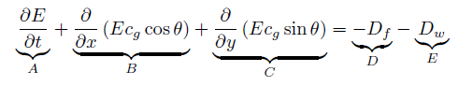

By assuming that one or more of the terms in the above equation is/are zero, we end up with the equation from which the algebraic formulations for both coefficients follow.

*Check the term(s) that is/are NON-ZERO.*

|  |  |  |
| --- | --- | --- |
|  |  | A |
|  |  | B |
|  |  | C |
|  |  | D |
|  |  | E |

Consider a shore-normal breakwater as in the below figure (top-view) that extends well beyond the natural surf zone.

Wave incidence is under an angle.

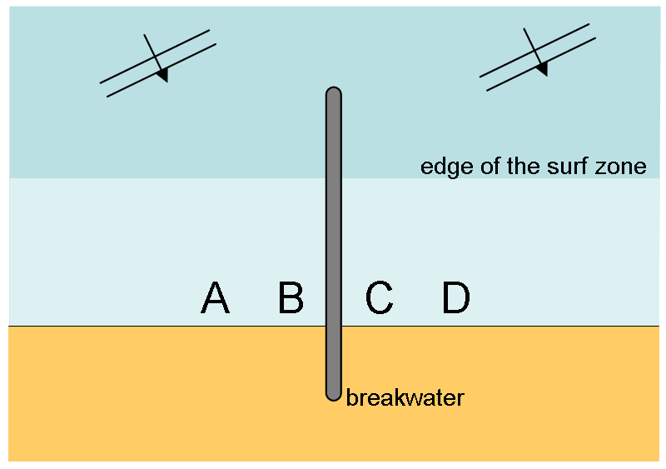

The structure induces a set-up gradient driven flow.

This flow is directed from: **   to **

In each of the below images, there is one phenomenon that dominates or is best visible. In one of the images the predominant phenomenon is diffraction, in a second image refraction and in a third image shoaling.

*Select which phenomenon dominates/is best visible in which image?*

|  |  |  |  |  |  |  |  |  |  |  |
| --- | --- | --- | --- | --- | --- | --- | --- | --- | --- | --- |
| |  |  |  | | --- | --- | --- | |  |  | Refraction | |  |  | Diffraction | |  |  | Shoaling | | https://mapleta-bsprod1.tudelft.nl:8443/mapleta/web/Cie4305000/Public_Html/waverefdif3/wrd3g.jpg |
| |  |  |  | | --- | --- | --- | |  |  | Refraction | |  |  | Diffraction | |  |  | Shoaling | | https://mapleta-bsprod1.tudelft.nl:8443/mapleta/web/Cie4305000/Public_Html/waverefdif3/wrd3a.jpg |
| |  |  |  | | --- | --- | --- | |  |  | Refraction | |  |  | Diffraction | |  |  | Shoaling | | https://mapleta-bsprod1.tudelft.nl:8443/mapleta/web/Cie4305000/Public_Html/waverefdif3/wrd3d.jpg |

Consider a coast as in the below figure:

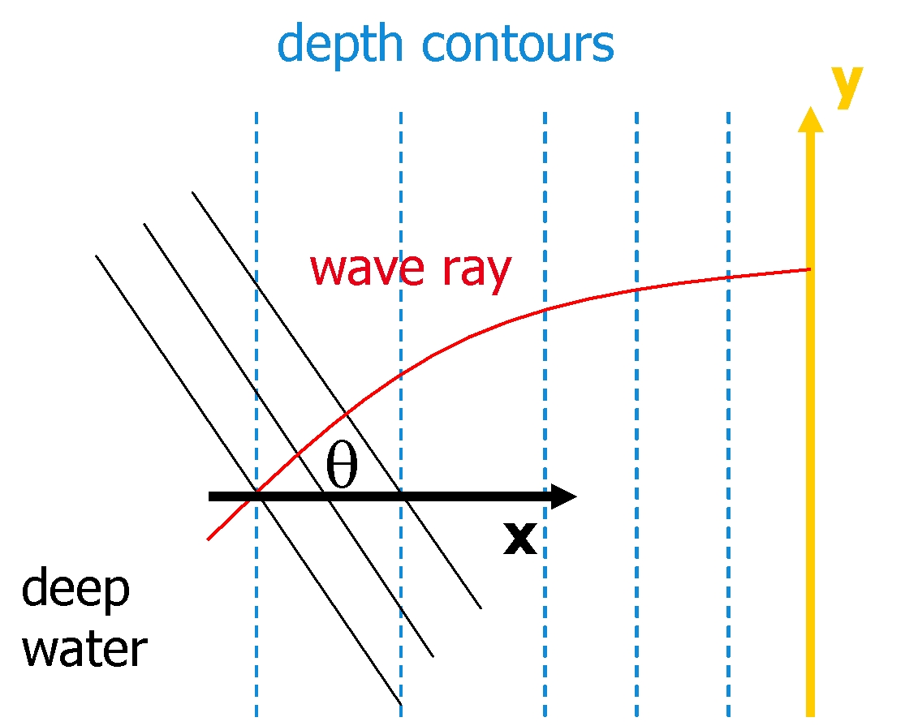

*For this situation, which of the following expressions for the alongshore wave force Fy is incorrect:*

|  |  |  |
| --- | --- | --- |
|  |  | Fy=−ddx(Ensinθcosθ) |
|  |  | Fy=−dSyydx |
|  |  | Fy=Dcsinθ |

In these expressions:

* S is the radiation stress (with the first index indicating its direction and the second index indicating the normal of the plane it works on).
* n is the ratio of the group velocity cg over the phase velocity c and E is the wave energy.
* D is the wave dissipation.

*So-called Longuet-Higgins streaming:*

|  |  |  |
| --- | --- | --- |
|  |  | varies on the time-scale of the oscillatory motion: TRUE |
|  |  | varies on the time-scale of the oscillatory motion: FALSE |
|  |  | is located near the bottom of the water column: TRUE |
|  |  | is located near the bottom of the water column: FALSE |

Waves are normally incident (i.e. zero wave angle) to a stretch of coast along which a detached shore-parallel breakwater is located.

*For the waves behind the breakwater:*

|  |  |  |
| --- | --- | --- |
|  |  | the wave height  increases with the alongshore distance from the breakwater tips: TRUE |
|  |  | the wave height  increases with the alongshore distance from the breakwater tips: FALSE |
|  |  | the wave angle increases with the alongshore distance from the breakwater tips: TRUE |
|  |  | the wave angle increases with the alongshore distance from the breakwater tips: FALSE |